|  |  |
| --- | --- |
| **BAG FILTER** | |
|  |  |

|  |  |
| --- | --- |
| **DAMPERS** | **DISHENDS** |
|  |  |

|  |  |
| --- | --- |
| **EVAPORATOR AND CONDENSER SHELL ASSEMBLY** | |
|  |  |

|  |  |
| --- | --- |
| **HOT AIR GENERATOR** | |
|  |  |

|  |  |
| --- | --- |
| **MARINE WATER BOX** | |
|  |  |

|  |  |
| --- | --- |
| **FURNACE** |  |
|  | |

|  |
| --- |
| **OIL SEPARATORS** |
| Skid Assembly |

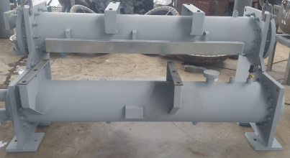

|  |  |
| --- | --- |
| **Stainless Steel Ducting and Structure** | |
|  |  |

|  |  |
| --- | --- |
| **Traw Mill and Screen** | |
|  |  |
|  | |